**Observation 32-packages**

**Create a package:**

CREATE OR REPLACE PACKAGE arithmetic_pkg AS

FUNCTION factorial(n IN NUMBER) RETURN NUMBER;

END arithmetic_pkg;

/

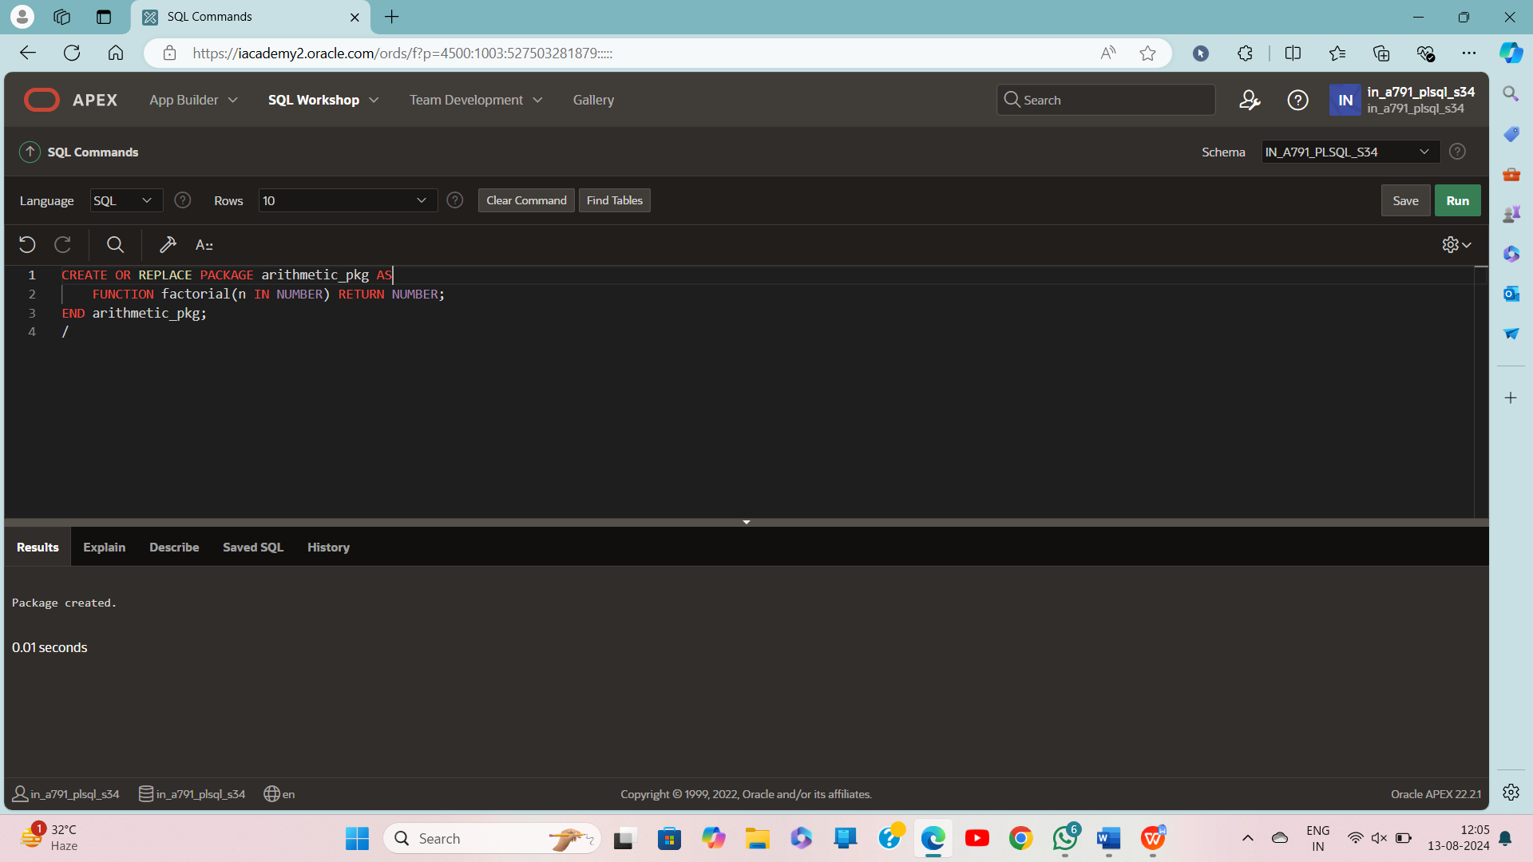

**Create body package:**

CREATE OR REPLACE PACKAGE BODY arithmetic_pkg AS

FUNCTION factorial(n IN NUMBER) RETURN NUMBER IS

result NUMBER := 1;

BEGIN

FOR i IN 1..n LOOP

result := result * i;

END LOOP;

RETURN result;

END factorial;

END arithmetic_pkg;

/

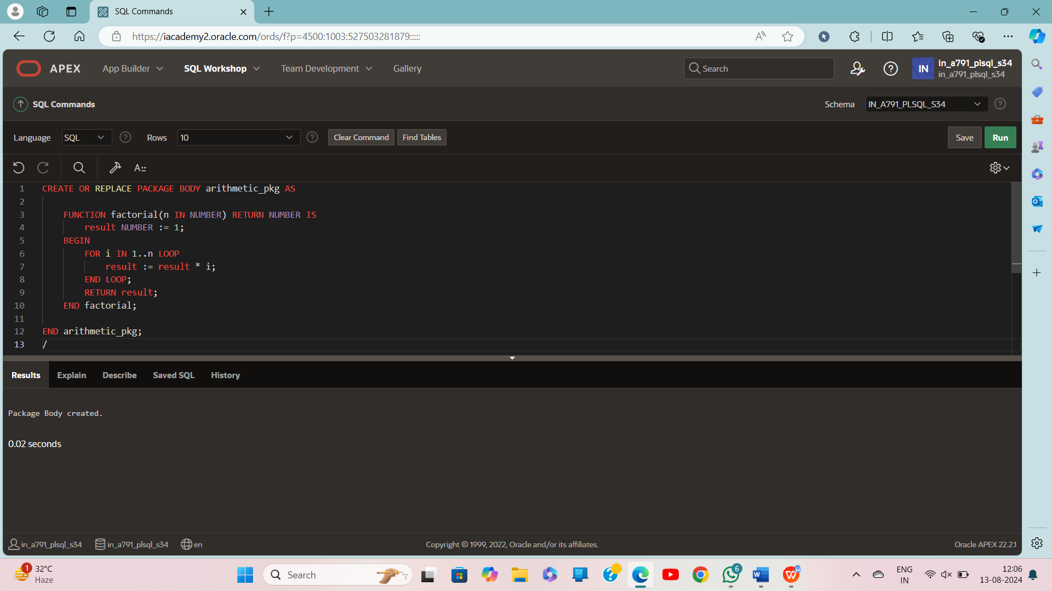

BEGIN

-- Declare a variable to store the result

DECLARE

v_number NUMBER := 5;

v_result NUMBER;

BEGIN

-- Call the factorial function from the package

v_result := arithmetic_pkg.factorial(v_number);

-- Print the result

DBMS_OUTPUT.PUT_LINE('Factorial of ' || v_number || ' is: ' || v_result);

END;

END;

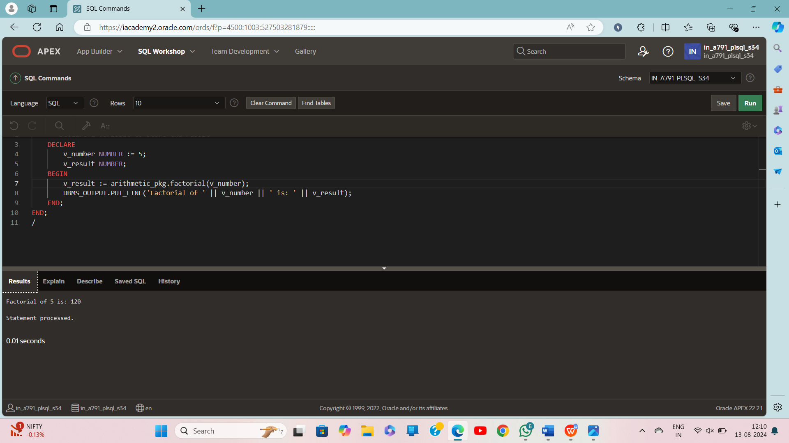

CREATE OR REPLACE PACKAGE emp_pkg IS

TYPE emp_rec IS RECORD (

emp_id NUMBER,

emp_name VARCHAR2(100),

emp_salary NUMBER

);

PROCEDURE display_emp(emp IN emp_rec);

END emp_pkg;

/

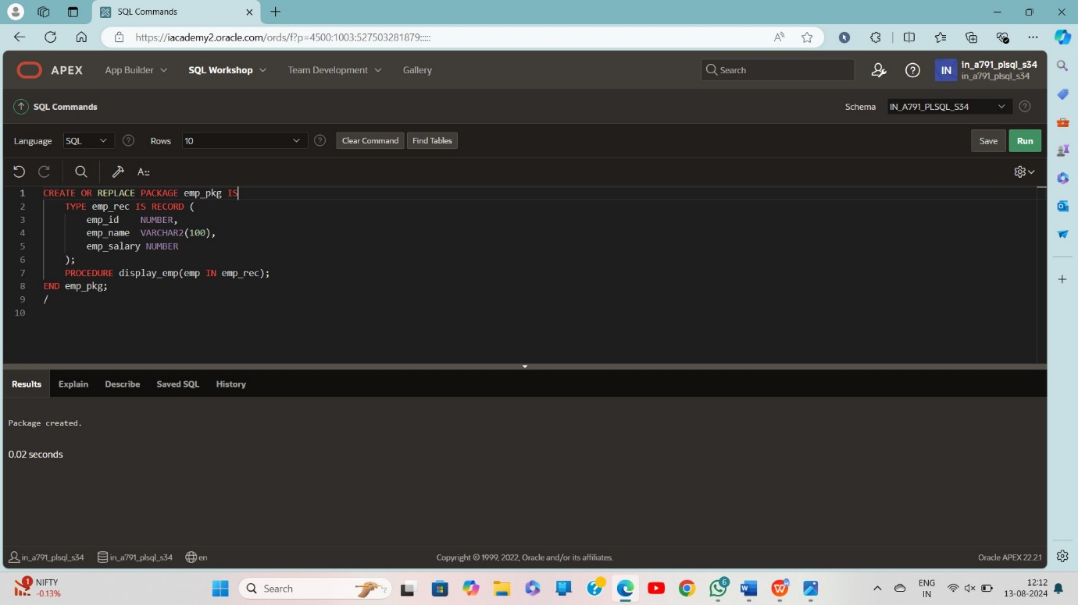

CREATE OR REPLACE PACKAGE BODY emp_pkg IS

PROCEDURE display_emp(emp IN emp_rec) IS

BEGIN

DBMS_OUTPUT.PUT_LINE('Employee ID: ' || emp.emp_id);

DBMS_OUTPUT.PUT_LINE('Employee Name: ' || emp.emp_name);

DBMS_OUTPUT.PUT_LINE('Employee Salary: ' || emp.emp_salary);

END display_emp;

END emp_pkg;

/

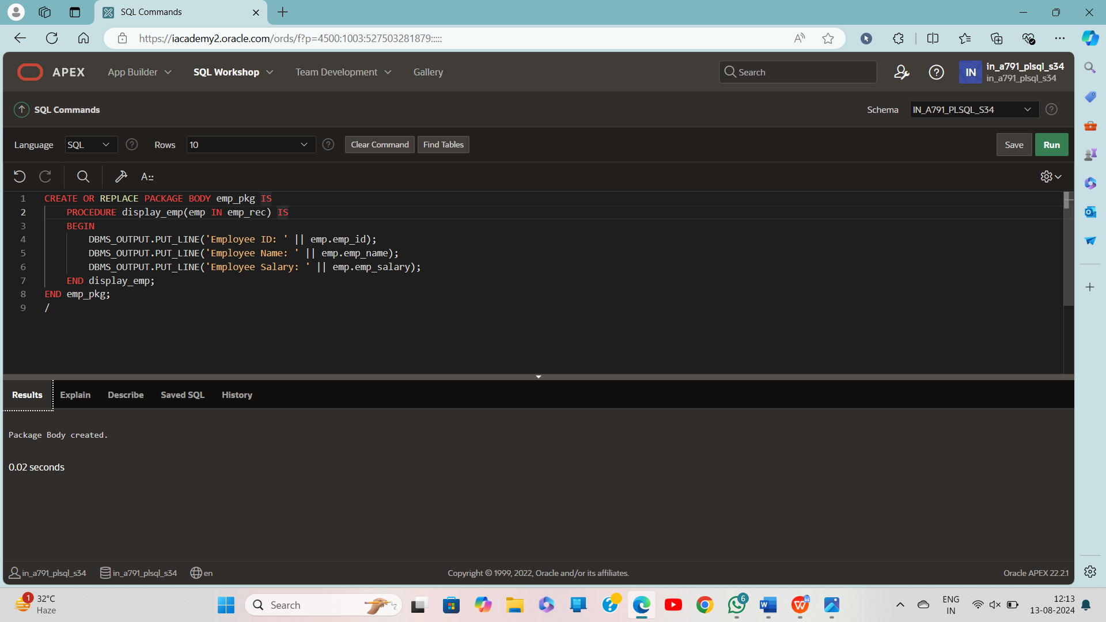

DECLARE

emp_info emp_pkg.emp_rec;

BEGIN

emp_info.emp_id := 1001;

emp_info.emp_name := 'John Doe';

emp_info.emp_salary := 60000;

emp_pkg.display_emp(emp_info);

END;

/

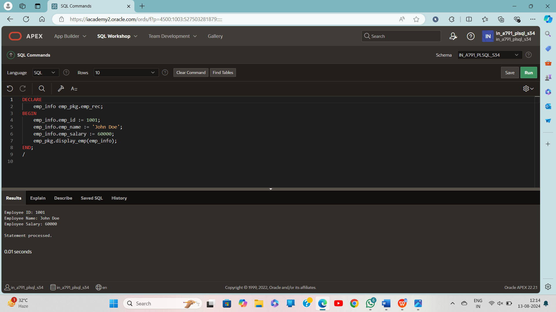

CREATE OR REPLACE PACKAGE library_pkg IS

TYPE book_rec IS RECORD (

book_id NUMBER(6),

title VARCHAR2(100),

author VARCHAR2(100)

);

TYPE book_table IS TABLE OF book_rec INDEX BY PLS_INTEGER;

PROCEDURE add_book(

p_books IN OUT book_table,

p_book_id IN NUMBER,

p_title IN VARCHAR2,

p_author IN VARCHAR2

);

PROCEDURE list_books(p_books IN book_table);

END library_pkg;

/

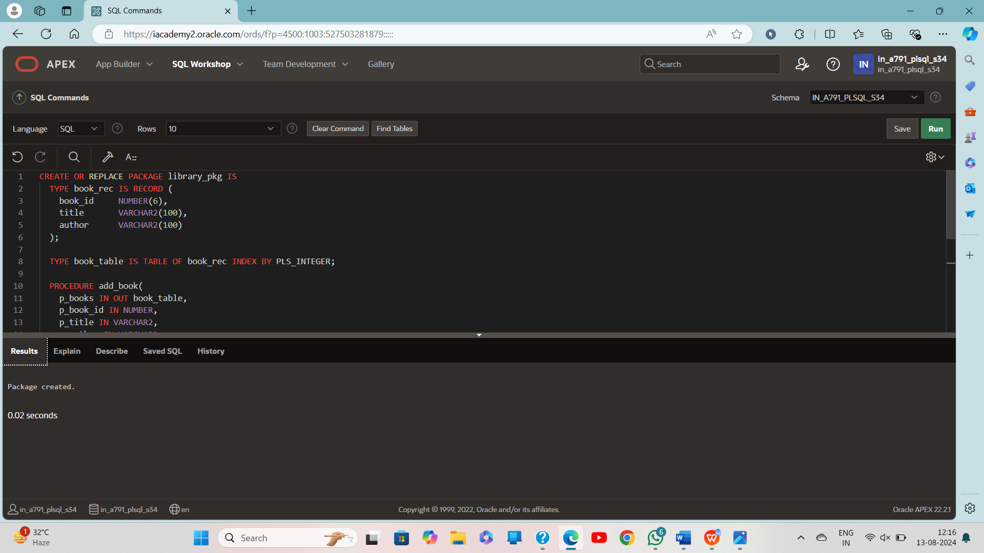

CREATE OR REPLACE PACKAGE BODY library_pkg IS

PROCEDURE add_book(

p_books IN OUT book_table,

p_book_id IN NUMBER,

p_title IN VARCHAR2,

p_author IN VARCHAR2

) IS

l_index PLS_INTEGER := p_books.COUNT + 1;

BEGIN

p_books(l_index) := book_rec(p_book_id, p_title, p_author);

END add_book;

PROCEDURE list_books(p_books IN book_table) IS

BEGIN

FOR i IN 1..p_books.COUNT LOOP

DBMS_OUTPUT.PUT_LINE(p_books(i).book_id || ' - ' || p_books(i).title || ' by ' || p_books(i).author);

END LOOP;

END list_books;

END library_pkg;

/

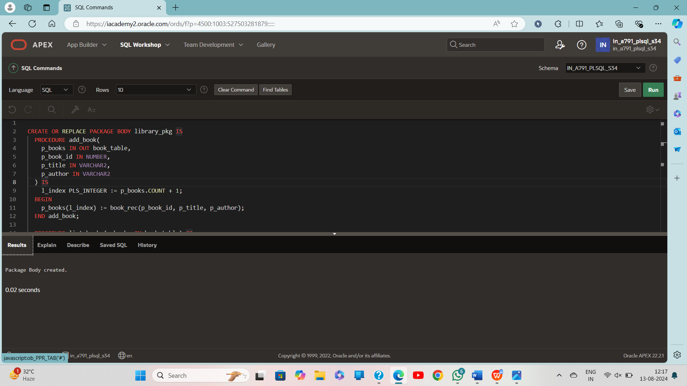

DECLARE

books library_pkg.book_table;

BEGIN

-- Add books to the collection

library_pkg.add_book(books, 1, 'The Catcher in the Rye', 'J.D. Salinger');

library_pkg.add_book(books, 2, 'To Kill a Mockingbird', 'Harper Lee');

library_pkg.add_book(books, 3, '1984', 'George Orwell');

-- List all books

library_pkg.list_books(books);

END;

/

